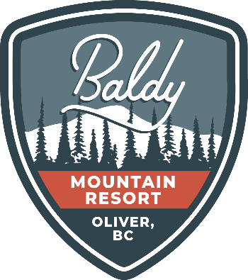

JOB DESCRIPTION – SUMMER TRAIL PATROL

Reports to: Operations Manager
Terms of Employment: part-time, seasonal, weekends and holidays; late June-September 2021
Expected Start Date: TBD

Who we are:
Baldy Mountain Resort is a family focused resort located in the South Okanagan, BC – and in operation since 1968. Our focus is to continually build fun experiences that leave lasting impressions with our guests and staff, as they create mountain memories. If this sounds like a culture you would like to be a part of, then check out this opportunity!
Job Overview
The Summer Trail Patrol will be responsible for ensuring the safety of Baldy Mountain Resort guests and staff both on our summer trail system as well the base area and surrounding areas.

Responsibilities
- Assist in ensuring the ongoing safety of guests and staff by checking trails and surrounding areas for hazards.
- Provide first aid and other assistance to guests and staff.
- Ensure all markings and signage on trails are maintained as well as monitor trails for hazards.
- Provide feedback and input to improve trail network.
- Report all hazards and incidents to the Operations Manager.
- Handle all interactions with guests and staff in a professional manner.
- Off-road vehicle operation
- Lift evacuations.
- Other duties as assigned.

Qualifications:
- Current OFA 3 or Wilderness First Responder or EMR (license)
- Previous experience with ski patrol preferred
- Previous lift evacuation experience is preferred
- Trail building and maintenance experience an asset
- Strong leadership, communication, and time management skills
- Must be a team player and able to work well with others while maintaining a calm & positive attitude, sometimes during high stress
- Good physical condition (ability to lift heavy objects, constant walking on uneven ground, & must be comfortable working at heights.)
- Ability to work outside for extended periods in adverse conditions.
- Climbing and belay experience an asset.
- Valid Class 5 driver’s license & clear driver’s abstract
- Must be willing to travel to the mountain and work weekends and holidays as required.
- Proficient in Microsoft Office and other basic computer systems and applications.

To apply, please send a copy of your cover letter, resume and relevant qualifications to Randy Murphy at operations@skibaldy.com with the email subject line “Application: Summer Trail Patrol”.

